DigiQUALTM: a Digital Library Evaluation Service

by Martha Kyrillidou, Fred Heath, Colleen Cook, Bruce Thompson, Yvonna Lincoln, and Duane Webster

Research Paper Presented at the 7th northumbria international conference on performance measurement in libraries and information services (pm7), 13-16, august 2007, south africa

ABSTRACT
What are the components of digital library service and how do we evaluate digital library services? The development of the DigiQUAL™ protocol and its implementation at UTOPIA and other NSDL collections is described. Based on the tradition and success of traditional libraries in focusing on the needs and preferences of their users, DigiQUAL™ is based on successful LibQUAL+™ experiences. Digital libraries (DLs) are facing the need to emphasize user-based evaluation. The original attitude of ‘we will build it and they will come” is not sufficient as competition for scarce resources is felt acutely both by traditional and digital libraries. The development of DigiQUAL™ uses a mixed methods approach, both qualitative and quantitative methods, for evaluating DLs. The development of a qualitative model based on focus groups conducted at the Digital Library for Earth System Information (DLESE) and Multimedia Educational Resource for Learning and Online Teaching (MERLOT) was the basis for the development of a rich item bank that was used for gathering feedback on the qualities of a website that users deem important. UTOPIA, a digital library developed and supported by the University of Texas was one of the first DLs to implement DigiQUAL™ together with other NSDL collections. The findings suggest that there are similarities among the digital library collections in terms of the items they selected. This paper has implications about how we view and describe digital libraries and attempts to define the boundaries between digital libraries and the rest of the web wide world.

- DIGITAL LIBRARIES AND DigiQUAL™

Introduction
The National Science Foundation (NSF) has funded the development of digital libraries since the early 1990s. As part of that funding there has always been a component of digital library evaluation that approaches digital libraries from a sociotechnical perspective and attempts to evaluate digital libraries from a user interaction perspective rather than a merely technical component. Digital libraries (DLs) are at the intersection of computing, communications and control technologies. DLs are using technologies and computing to enhance communication and learning [1] and are often facing the challenge of developing assessment and evaluation tools that aim at understanding the self-sufficient information seeker that anonymously may navigate the world of the internet. For DLs to be successful, this anonymous user has to develop a sense of ownership and pride in the resources that are developed and used, and assign value in the delivery of information that is received through DLs.

In this paper, we are building upon the work that has taken place in a variety of fields. In a collection of articles on Digital Library Use some of the early thinkers and researchers in this area present their hybrid perspectives: “socially grounded DL research is defined more by the phenomena in which it is interested and its sociotechnical orientation than by specific methods, theories or approaches.”[2] The DL evaluation protocol known as DigiQUAL™[3] builds upon the experience of the LibQUAL+™ evaluation protocol, the largest and most scalable user-based evaluation protocol ever implemented in traditional libraries.[4] Figure 1 shows a world map with the 600 libraries that have implemented LibQUAL+™ over the last four years, gathering feedback from thousands of library users [5,6]. Based on the LibQUAL+™ tradition, DigiQUAL™ has strong ties to the theories and methods of the market services field and builds upon the two decades of work behind the development of the SERVQUAL protocol where LibQUAL+™ was based.[7,8,9,10]
Figure 1. World LibQUAL+™ Map, 2005
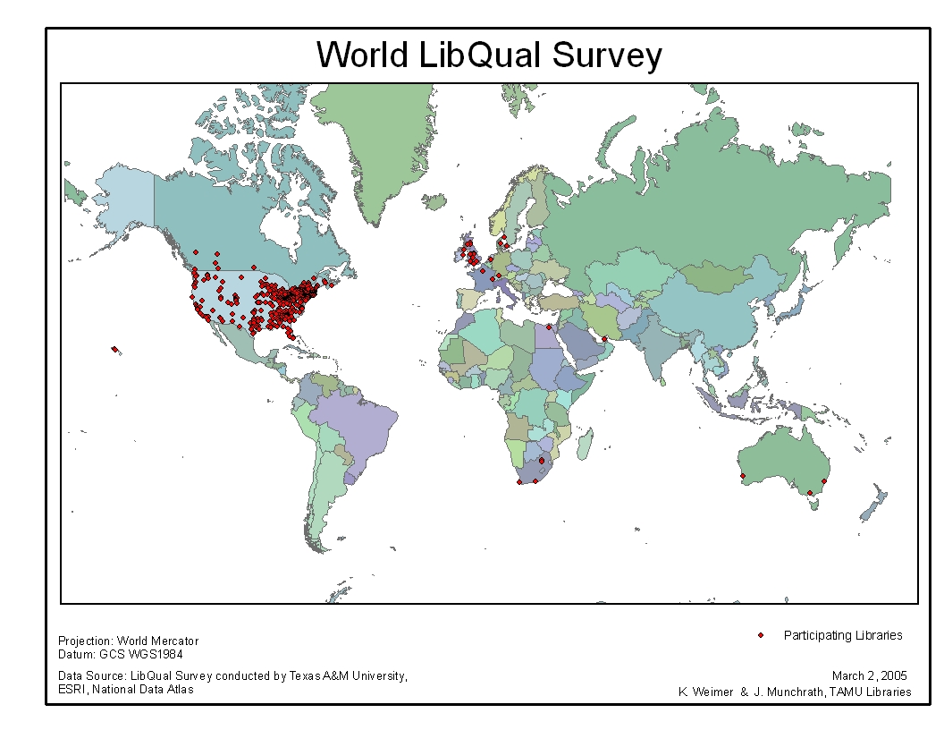

DigiQUAL™
DigiQUAL™ is the development of a set of evaluation services for understanding users, how they interact with digital libraries and how they create new knowledge using DLs. Rich qualitative work was done in a variety of settings including: (a) the rich corpus of 70 in-depth, person-to-person interviews across 12 research libraries in North America [11,12]; (b) focus groups held at two major NSDL partner libraries, DLESE and MERLOT [13]; (c) the experience of ARL from the ARL E-Metrics project [14]; and (d) extensive analysis of a small sample of comments received from 5,000 users across 20 research libraries that participated in LibQUAL+™ [15].
The web survey interface – created through collaboration between ARL, Texas A&M University Libraries, and the University of Texas – evaluates digital libraries from the user perspective and emphasizing issues related to the reliability and trustworthiness of a Web site. Because their services are available to large communities of users, digital libraries need systematic evaluation by those users. DLs seek efficient and effective ways to deliver high quality service using electronic resources. The ability to assess the service quality of DLs will allow them to improve the retrieval of relevant information, promote user preparation for an information-rich society, and promote scholarship and lifelong learning. The DigiQUAL™ protocol is re-grounding LibQUAL+™ for use in the digital library environment and has been supported by funding from the National Science Foundation’s (NSF) National Science Digital Library (NSDL) program [16]. Its goals include:
- Defining the dimensions of digital library service quality from the perspective of the users;
- Creating a tool for measuring user perceptions and expectations of digital library service quality across NSDL digital library contexts;
- Identifying digital library "best practices" that permit generalizations across operations and development platforms;
- Enhancing student learning by managing effectively user perceptions and expectations of digital library services;
- Establishing a digital library service quality assessment program as an integral part of the library service quality assessment program at the Association of Research Libraries; and
- Institutionalizing continuous product and process evaluation efforts directed toward positive and timely management of outcomes.

Methodological considerations
Based on the focus groups held at DLESE and MERLOT, a model was developed based on the analysis of the transcripts that describes the Digital Library Environment (see figure 2).

According to the qualitative model emerging, there are two major components in the DL environment, the Human/System Interaction component and the Technical Component. The content that is located in a DL is mostly subject to the requirements of the technical environment; the community of creators and users forms the human/system interaction of a DL environment. That community may act as a social network often concerned with preservation, may engage people in a ‘give and take’ action, and be concerned with the propagation of the community. Quality in this environment is defined by the dynamic interaction between content (information) and the community (users) in a two-way, reciprocal relationship that is often institutionalized as a “vetting” or review process. In trying to understand how users approach content and community, we developed a series of conceptual categories that characterize content and they include issues related to: access, reliability, trustworthiness and accuracy, scope and sequence, the maintenance of active links and the ability to browse. Users are also characterized by their desire to navigate, to be self-sufficient, to trust the veracity of the information, to use it, and to fulfill their purpose, i.e. to accomplish a useful task.
Figure 2. Digital Library Environment

Technical Composition
Human/System Interaction
Content
CommunityCreator/Use
Vetting Process
Access
Reliability
Trustworthiness/
Accuracy
Scope & Sequence
Active Links
Browsability
Organized
Navigability
Self-sufficiency
Trustworthiness (feels “right)
Usability
Fulfills purpose/useful
As a social net
Takers & Givers
Preservation
Propagation
Figure 2. DIGITAL LIBRARY ENVIRONMENT

Using the emerging qualitative model as our basis we attempted to create a series of questions grounded in the words of the users who participated in the focus groups reflecting the conceptual categories that characterize content and community. We developed an item bank of more than 250 questions originally but reduced it after examining the items for overlap. Each survey item was assigned two scales, an importance scale and a performance scale and this format preserves the concept of a gap analysis that has been so helpful in other library settings. Each scale has a 7-point Likert scale response format.

The protocol implemented in spring 2005 includes a question bank of more than 180+ items that were developed through a mixed-methods approach combining both qualitative and quantitative research methods as described. It is also building on the LibQUAL+™ model of evaluating library service quality both in terms of the methods used, overlap on themes, and utilization of the technology infrastructure both in terms of hardware and software implementation. DigiQUAL™ items have been developed from a mix of modified original LibQUAL+™ items that are applicable in the digital library environment, and from focus groups transcripts with users at the digital libraries of MERLOT and DLESE based on the model described above. In the DigiQUAL™ protocol from the extensive bank of questions, each user will be faced with five randomly chosen questions.

The protocol uses matrix sampling procedures to create an aggregated profile for a given library. In the presence of a large item pool, each survey participant completes a randomly selected subset of items (e.g., five items), rather than responding to every item. This means each participant's workload is minimized, by distributing the work of rating all the items across the entire respondent pool. Even though each item is not completed by every participant, because the item assignment is randomized, roughly the same number of people rate each item, and the total pool of responses should approximate the profile that would be created if every participant had completed every item.

Several customization features are being developed as the survey is implemented in different DL settings. For example, we have built a mechanism to track the different approaches of soliciting users to take the survey. Digital libraries may collect additional information about the URL distribution method of the surveys by adding an optional code to the end of the above URLs. These codes are entered into the database along with the other survey details for later analysis. Coded URLs can be used to track different subgroups, distribution methods, dates of inviting people to take the survey, and other characteristics that may be important to track at the local level (figure 3).
Figure 3: Coded URL from the DigiQUAL™ Preferences Section
To use this feature, the URL needs to be amended with the following:
&code=???
(where ??? is whatever code you want, any length, letters and/or numbers) at the end of the URL. For example, if a digital library was distributing the survey via email and via the web, they could use:
Web: http://survey.libqual.org/digiqual/index.cfm?ID=328792
&code=123
Email: http://survey.libqual.org/digiqual/index.cfm?ID=328792
&code=456
Of course, if they are only using one distribution method, it is not necessary to add this code

- UTOPIA
The first site to implement the DigiQUAL™ protocol is UTOPIA, a digital library developed at the University of Texas at Austin. UTOPIA is an ambitious initiative designed to open the University’s doors of knowledge, research, and information to the public at large. In the words of UT President Larry R. Faulkner, “We will provide access for every citizen, via a personalized Internet window, into the resources of our libraries, collections, museums, and much more. The University is a dynamo, now with the power to bring light into every home and business in Texas, and we mean to realize that potential.”

President Faulkner’s vision and his belief in the ability of the university to disseminate a virtual vision of its riches are borne out by an analysis of web site traffic by Alexa, an analysis component of Amazon.com. The University of Texas at Austin is one of the most heavily visited educational websites in the English-speaking world as Figure 4 charts illustrate.
Figure 4. Daily Reach of University Sites by Alexa
It is also highly-regarded, with a “five-star” rating reported on the same site. The web pages of the University of Texas Libraries are the target of those web visits almost one-third of the time:
Figure 5. % of Visitors to go to the library from university web site

The Libraries’ Google-accessible virtual map collection serves as an example of the popularity of the University of Texas web site. Its large map collections, carefully-assembled over the decades, are visited many thousands of times a month by students and scholars. However, the six thousand maps that Paul Rascoe (head of the maps unit) and his colleagues have selected and made available over the web draw a hundred million visitors annually. Similar heavy web traffic is recorded by the library-hosted Virtual Handbook of Texas and by the digital version of the Gutenberg Bible.

After almost two years of development, combining the fund-raising acumen of the Development Office and the technical skills of the Information Technology Services (ITS) and the Digital Library Services Division of the University of Texas Libraries (UTL), on-going responsibility for UTOPIA operations was assigned to the latter. As design on the still-young site continues, attention was also turned to issues of assessment.

After accepting oversight, one of the immediate concerns of library leadership was to establish a credible assessment component for UTOPIA that enabled designers to evaluate its performance from the eyes of its multiple audiences: teachers, students, families and the informed citizenry generally. In essence, an evaluation tool was sought that would enable assessment of UTOPIA’s performance by a diverse K-to-gray constituency. How useful to the various groups find the UTOPIA site to be? Are their questions being answered? Their needs met?

The main drivers related to the digital library evaluation protocol implemented for UTOPIA are reflected in: (1) The University of Texas Libraries’ demonstrated commitment to assessment, (2) the requirements of granting agents, and (3) the prospect of using the performance data as a means for assisting UTOPIA partners with subsequent granting efforts of their own. The UTL have employed the LibQUAL+™ each year, and work systematically to interpret and employ its results. Similarly, some of the granting agencies that assisted with the launch of UTOPIA asked that an assessment tool be in place in order to facilitate the on-going improvement of the site. And finally, both the UTOPIA developers and contributors to the site recognized that if faculty and site designers could point to convincing data regarding its acceptance and effectiveness, future rounds of grant-seeking would have an enhanced prospect of success.

UTOPIA staff initially placed a link on the website that enabled site visitors to follow and fill in the survey. While site visitation numbers continued to grow, a passive “please take our survey” did not induce many site visitors to respond. For whatever reasons, few accepted the invitation to initiate the survey link.

The UTOPIA design team decided that a more active approach was needed. An earlier usability survey used for site development had offered an incentive to induce responses. Building on that example, the UTOPIA and DigiQUAL™ design teams elected to add an email field that allows UTOPIA to offer incentives to people who take the survey. Smaller prizes over shorter intervals is the idea now being tested as this paper goes to draft. As an approach a monthly incentive is currently being tested. Because visitors to the site come from around the world, a prize that did not require mail delivery was needed. A monthly award of a gift card to a prominent on-line book vendor was being considered at the deadline for the delivery of this draft. Because the new plan will require the retention of email addresses on a temporary basis, the UTOPIA team is also in the process of taking the proposal before the IRB. The outcome of these efforts will be discussed at the conference.
In summary, UTOPIA is viewing DigiQUAL™ as an on-going assessment tool for collecting data and building a community within targeted communities in Texas and beyond. There are still technical problems to be overcome, methodological issues to be resolved, and pragmatic steps yet to be implemented. But progress has been made both within UTOPIA in seeing assessment as a mechanism for building community and across digital libraries as we are implementing DigiQUAL™ in other NSDL digital collection settings.

- ASSESSING THE FUTURE OF LIBRARIES
In the past, library assessment has often focused on resource inputs such as acquisitions, expenditures, staff levels, and legacy collections in order to determine excellence and measure progress toward the broad goals of ready access to needed information. Today, the focus of assessment methodologies is much more oriented toward measuring outputs such as level of activities and deliverables as well as developing a better understanding of the impact of those outputs on the success and satisfaction levels of the user.
In the future, technology is likely to change the playing field for library assessment once again. Increasingly, there is a blurring of lines between resource availability, utilization of discovery tools, skilled use of information, and effective expression of the creative process. The speed of interaction among these activities and the impact of this interaction on the assessment process needs further exploration. Knowing what and when to measure in the electronic world is essential to assuring agile response to rapidly changing information milieu. The goal is universal access to information. Measuring success in this networked distributed environment is a supreme challenge.

- REFERENCES

- K. A. Renninger and W. Shumar, eds. Building Virtual Communities: Learning and Change in Cyberspace (Cambridge, UK: Cambridge University Press, 2002)
- A. P. Bishop, N. A. Van House, and B. P. Buttenfield, eds. Digital Library Use: Social Practice in Design and Evaluation (Cambridge, MA: MIT Press, 2003).
- Colleen Cook, Fred Heath, Martha Kyrillidou, Yvonna Lincoln, Bruce Thompson, Duane Webster, Developing a National Science Digital Library (NSDL) LibQUAL+™ Protocol: An E-service for Assessing the Library of the 21st Century, reviewed paper presented at the October 2003 NSDL Evaluation Workshop. http://www.libqual.org/documents/admin/NSDL_workshop_web1.pdf
- LibQUAL+™ is a web-based survey used by traditional libraries that measures library service quality across three dimensions: (a) affect of service, (b) library as place, and (c) information control. It has been applied at more than 600 libraries since 2000 and currently the database includes data from more than 350,000 users from the US, Europe, Australia and in the upcoming year it will include institutions from South Africa.
- Cook, Colleen, Fred Heath, and Bruce Thompson. "LibQUAL+(TM) from the UK Perspective." Paper presented at the 5th Northumbria International Conference, Durham, UK 2003.
- Kyrillidou, Martha, Toni Olshen, Fred Heath, Claude Bonnelly, and Jean-Pierre Cote. "Cross-Cultural Implementation of LibQUAL+™: The French Language Experience." Paper presented at the 5th Northumbria International Conference, Durham, UK, July 29 2003.
- Heath, Fred M. 2002. “LibQUAL+™: A Methodological Suite.” portal: Libraries and the Academy 2 (1): 1-2.
- Thompson, Bruce, Colleen Cook, and Russel L. Thompson. 2002. “Reliability and Structure of the LibQUAL+ Scores: Measuring Perceived Library Service Quality.” portal: Libraries and the Academy 2 (1): 3-12.
- Cook, Colleen, Fred Heath, and Bruce Thompson. 2002. “Score Norms for Improving Library Service Quality: A LibQUAL+™ Study.” portal: Libraries and the Academy 2(1): 13-26.
- Heath, Fred, Colleen Cook, Martha Kyrillidou, and Bruce Thompson. 2002. “ARL Index and Other Validity Correlated of LibQUAL+™ Scores.” portal: Libraries and the Academy 2 (1): 27-42.
- Heath, Fred and Colleen Cook. 2001. “Users’ Perceptions of Library Service Quality: A LibQUAL+ Qualitative Study” Library Trends 49 (4): 548-583.
- Lincoln, Yvonna S. 2002. Insights into Library Services and Users from Qualitative Research. Library & Information Science Research 24 (1):3-16.
- Yvonna Lincoln, Colleen Cook and Martha Kyrillidou, “Evaluating the NSF National Science Digital Library Collections,” Paper presented at the Multiple Educational Resources for Learning and Online Technologies (MERLOT) Conference, Costa Mesa, California, August 3-6, 2004. http://old.libqual.org/documents/admin/MERLOT%20Paper2_final.pdf
- Martha Kyrillidou and Sarah Giersch, Qualitative Analysis of ARL E-Metrics Participant Feedback about the Evolution of Measures for Networked Electronic Resources
Library Quarterly, 74 (4) (2004). http://www.journals.uchicago.edu/cgi-bin/resolve?LQ740402PDF
- Yvonna Lincoln, Colleen Cook and Martha Kyrillidou, “User Perspectives Into Designs for Both Physical and Digital Libraries: New Insights on Commonalities/Similarities and Differences from the NDSL Digital Libraries and LibQUAL+™ Data Bases “
7th ISKO-Spain Conference, The human dimension of knowledge organization, Barcelona 6-8, July, 2005. http://old.libqual.org/documents/admin/ISKO.PDF
- Martha Kyrillidou and Sarah Giersch, Developing the DigiQUAL Protocol for Digital Library Evaluation, JCDL - Joint Conference on Digital Libraries, Denver, CO, June 6-11, 2005. http://old.libqual.org/documents/admin/digiqual-jcdl05-v5.pdf

Authors

Brief autobiographical note for each author/contributor:

Martha Kyrillidou is directing the ARL Statistics and Measurement Program since 1994. She has been the editor of the ARL Statistics and the ARL Annual Salary Survey and one of the principal investigators in the development of LibQUAL+®. She has been involved in projects regarding the evaluation of electronic resources such as MINES for Libraries™, DigiQUAL™, and E-metrics. Prior to joining ARL, Martha was affiliated with the Library Research Center of the Graduate School of Library and Information Science at the University of Illinois at Urbana-Champaign, the Bureau of Education Research at Kent State University and the Aristotle University of Thessaloniki in Greece.

Bruce Thompson is Distinguished Professor and College Distinguished Research Fellow of Educational Psychology, and Distinguished Professor of Library Sciences, Texas A&M University. He is lead co-editor of the American Educational Research Journal (AERJ:TLHD), and past editor of Educational and Psychological Measurement, the series, Advances in Social Science Methodology, and two other journals. He is the author/editor of nearly 200 articles, and several books, including the recently published Foundations of Behavioral Statistics.

C. Colleen Cook is Dean and Director, Texas A&M University Libraries, College Station, TX, USA, and holder of the Sterling Evans Chair in Library Science. She chairs the standing ARL Statistics Committee, and has published extensively on library service quality assessment and improvement.

Fred Heath, University of Texas Libraries, University of Texas, Austin, TX, USA. He was one of the original developers of LibQUAL+® and under his leadership UTOPIA was funded at the University of Texas. He has published extensively on library service quality assessment and improvement.

Yvonna Lincoln, College of Education, Texas A&M University, College Station, TX 77843-4226, USA. She is one of the world’s premier qualitative researchers and has been an advisor to the development of both LibQUAL® and DigitQUAL™.

Duane Webster, ARL Executive Director. One of Duane’s career goals has been the cultivation of a culture of assessment that helps libraries improve and market their services by developing LibQUAL+® and other new assessment tools.

